**15. Intro to Deep Learning**

**15.1 A Single Neuron**

Using Keras and Tensorflow you'll learn how to:

* create a **fully-connected** neural network architecture
* apply neural nets to two classic ML problems: **regression** and **classification**
* train neural nets with **stochastic gradient descent**, and
* improve performance with **dropout**, **batch normalization**, and other techniques

**What is Deep Learning?**

Some of the most impressive advances in artificial intelligence in recent years have been in the field of *deep learning*. Natural language translation, image recognition, and game playing are all tasks where deep learning models have neared or even exceeded human-level performance.

So what is deep learning? **Deep learning** is an approach to machine learning characterized by deep stacks of computations. This depth of computation is what has enabled deep learning models to disentangle the kinds of complex and hierarchical patterns found in the most challenging real-world datasets.

Through their power and scalability **neural networks** have become the defining model of deep learning. Neural networks are composed of neurons, where each neuron individually performs only a simple computation. The power of a neural network comes instead from the complexity of the connections these neurons can form.

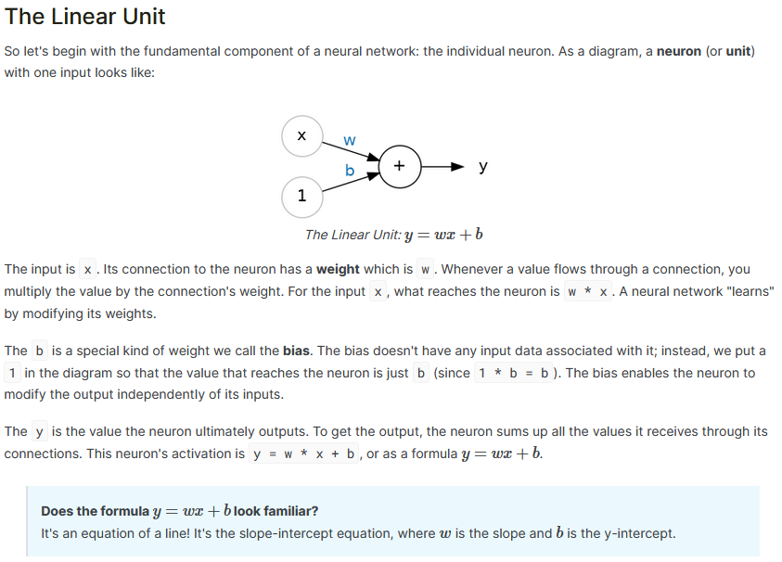

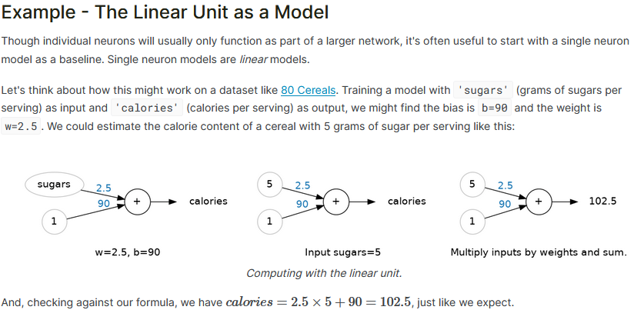

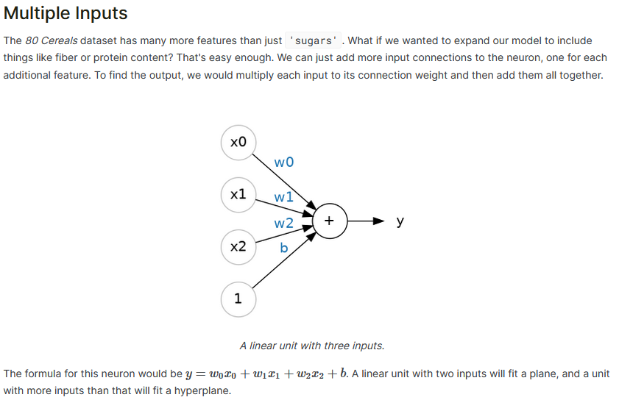

**15.2 Deep Neural Networks**

In this lesson we're going to see how we can build neural networks capable of learning the complex kinds of relationships deep neural nets are famous for.

The key idea here is *modularity*, building up a complex network from simpler functional units. We've seen how a linear unit computes a linear function -- now we'll see how to combine and modify these single units to model more complex relationships.

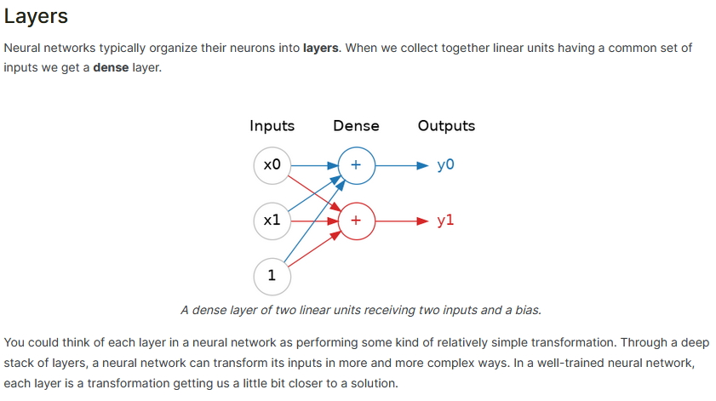

**Many Kinds of Layers**  
A "layer" in Keras is a very general kind of thing. A layer can be, essentially, any kind of *data transformation*. Many layers, like the [convolutional](https://www.tensorflow.org/api_docs/python/tf/keras/layers/Conv2D) and [recurrent](https://www.tensorflow.org/api_docs/python/tf/keras/layers/RNN) layers, transform data through use of neurons and differ primarily in the pattern of connections they form. Others though are used for [feature engineering](https://www.tensorflow.org/api_docs/python/tf/keras/layers/Embedding) or just [simple arithmetic](https://www.tensorflow.org/api_docs/python/tf/keras/layers/Add). There's a whole world of layers to discover -- [check them out](https://www.tensorflow.org/api_docs/python/tf/keras/layers)!

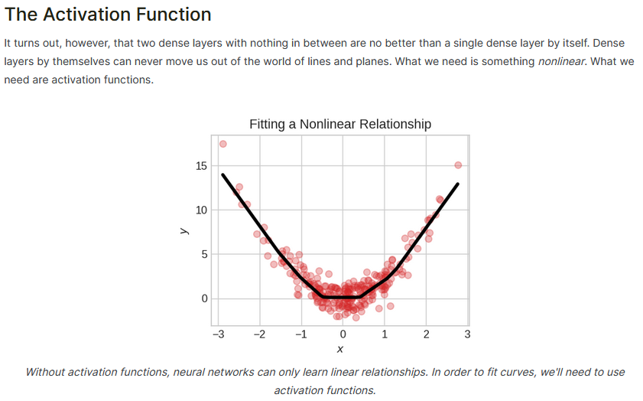

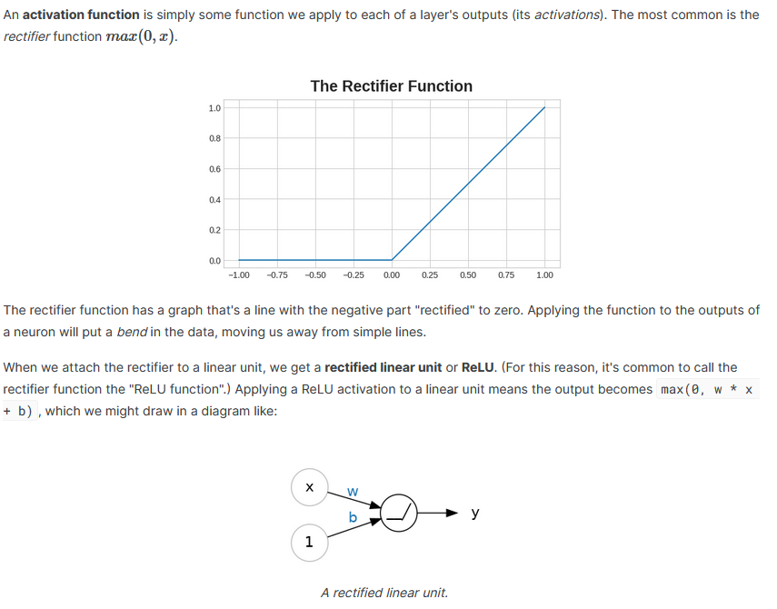ReLU

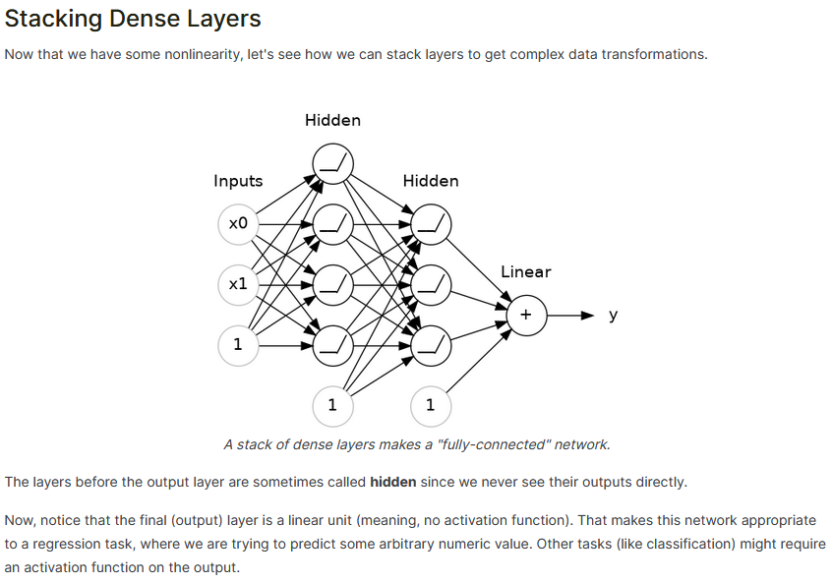

**15.3 Stochastic Gradient Descent**

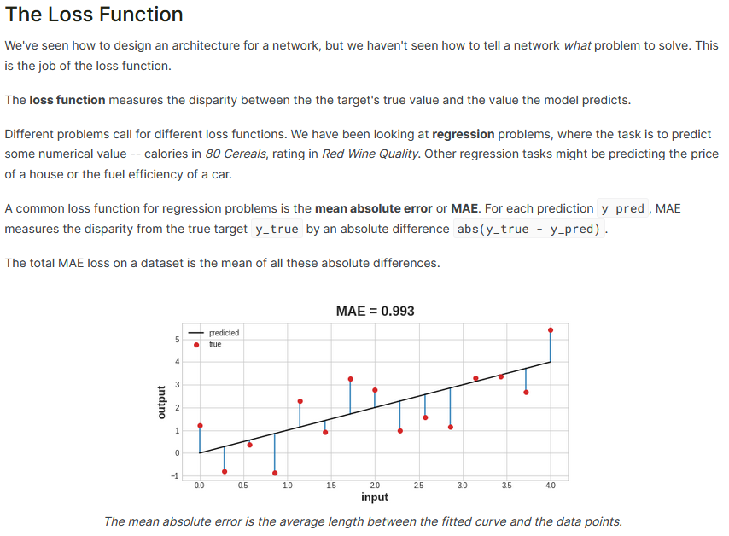

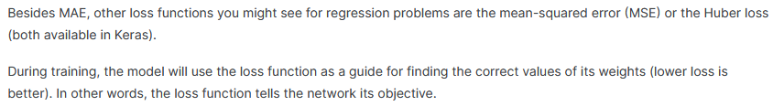

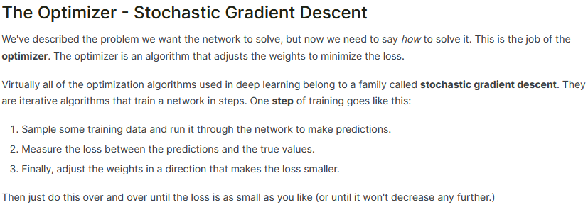



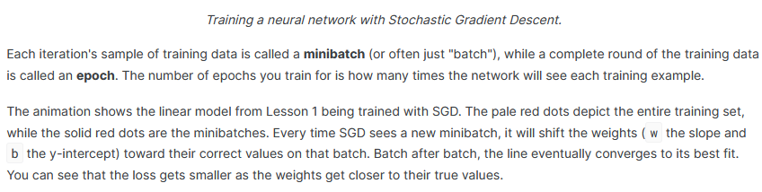

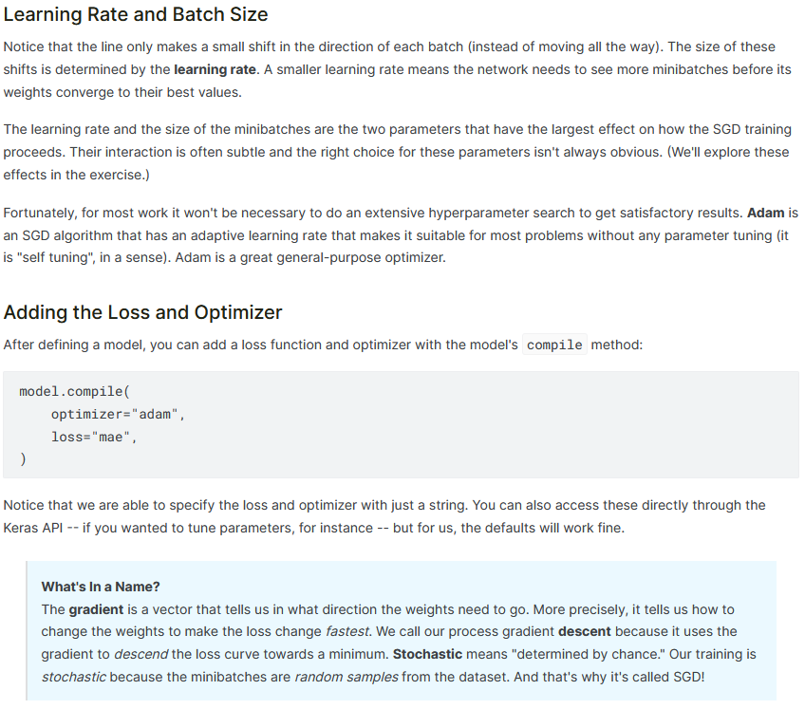

**15.4 Overfitting and Underfitting**

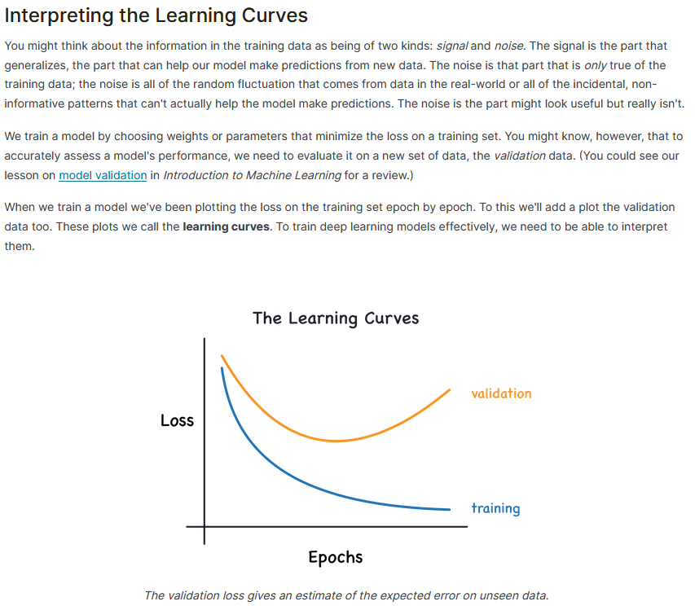

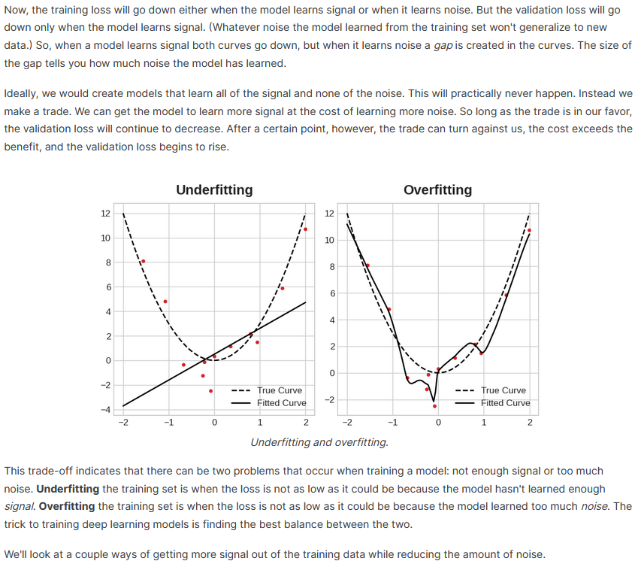

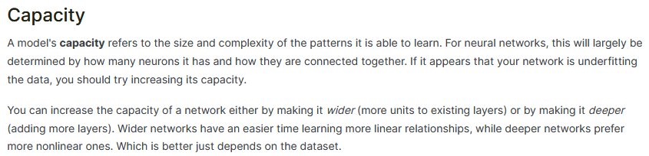

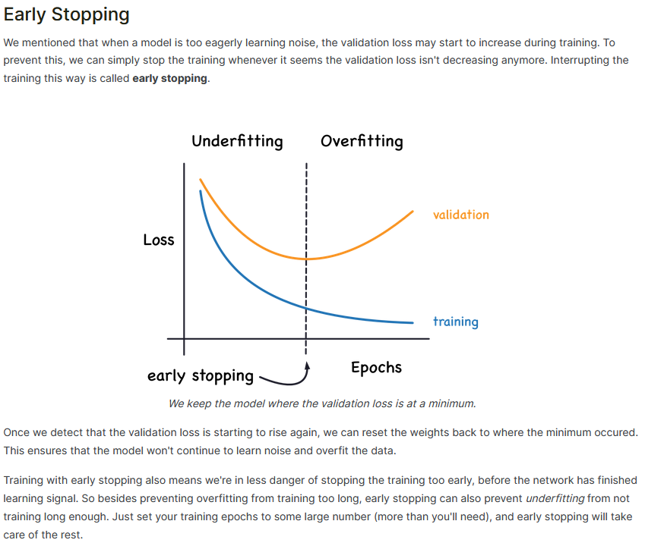

**15.5 Dropout and Batch Normalization**

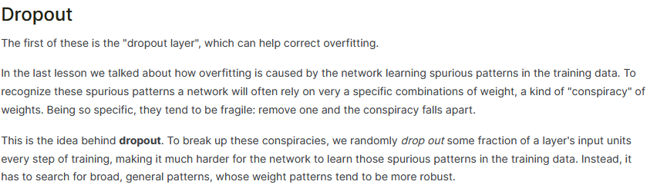



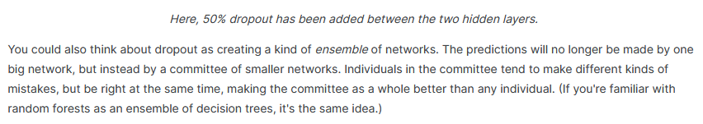

**Batch Normalization**

The next special layer we'll look at performs "batch normalization" (or "batchnorm"), which can help correct training that is slow or unstable.

With neural networks, it's generally a good idea to put all of your data on a common scale, perhaps with something like scikit-learn's [StandardScaler](https://scikit-learn.org/stable/modules/generated/sklearn.preprocessing.StandardScaler.html) or [MinMaxScaler](https://scikit-learn.org/stable/modules/generated/sklearn.preprocessing.MinMaxScaler.html). The reason is that SGD will shift the network weights in proportion to how large an activation the data produces. Features that tend to produce activations of very different sizes can make for unstable training behavior.

Now, if it's good to normalize the data before it goes into the network, maybe also normalizing inside the network would be better! In fact, we have a special kind of layer that can do this, the **batch normalization layer**. A batch normalization layer looks at each batch as it comes in, first normalizing the batch with its own mean and standard deviation, and then also putting the data on a new scale with two trainable rescaling parameters. Batchnorm, in effect, performs a kind of coordinated rescaling of its inputs.

Most often, batchnorm is added as an aid to the optimization process (though it can sometimes also help prediction performance). Models with batchnorm tend to need fewer epochs to complete training. Moreover, batchnorm can also fix various problems that can cause the training to get "stuck". Consider adding batch normalization to your models, especially if you're having trouble during training.

**15.6 Binary Classification**

Classification into one of two classes is a common machine learning problem. You might want to predict whether or not a customer is likely to make a purchase, whether or not a credit card transaction was fraudulent, whether deep space signals show evidence of a new planet, or a medical test evidence of a disease. These are all **binary classification** problems.

In your raw data, the classes might be represented by strings like "Yes" and "No", or "Dog" and "Cat". Before using this data we'll assign a **class label**: one class will be 0 and the other will be 1. Assigning numeric labels puts the data in a form a neural network can use.

**Accuracy and Cross-Entropy**

**Accuracy** is one of the many metrics in use for measuring success on a classification problem. Accuracy is the ratio of correct predictions to total predictions: accuracy = number_correct / total. A model that always predicted correctly would have an accuracy score of 1.0. All else being equal, accuracy is a reasonable metric to use whenever the classes in the dataset occur with about the same frequency.

The problem with accuracy (and most other classification metrics) is that it can't be used as a loss function. SGD needs a loss function that changes smoothly, but accuracy, being a ratio of counts, changes in "jumps". So, we have to choose a substitute to act as the loss function. This substitute is the *cross-entropy* function.

Now, recall that the loss function defines the *objective* of the network during training. With regression, our goal was to minimize the distance between the expected outcome and the predicted outcome. We chose MAE to measure this distance.

For classification, what we want instead is a distance between *probabilities*, and this is what cross-entropy provides. **Cross-entropy** is a sort of measure for the distance from one probability distribution to another.

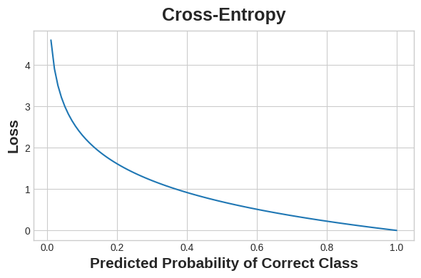

Cross-entropy penalizes incorrect probability predictions.

The idea is that we want our network to predict the correct class with probability 1.0. The further away the predicted probability is from 1.0, the greater will be the cross-entropy loss.

The technical reasons we use cross-entropy are a bit subtle, but the main thing to take away from this section is just this: use cross-entropy for a classification loss; other metrics you might care about (like accuracy) will tend to improve along with it.

**Making Probabilities with the Sigmoid Function**

The cross-entropy and accuracy functions both require probabilities as inputs, meaning, numbers from 0 to 1. To covert the real-valued outputs produced by a dense layer into probabilities, we attach a new kind of activation function, the **sigmoid activation**.

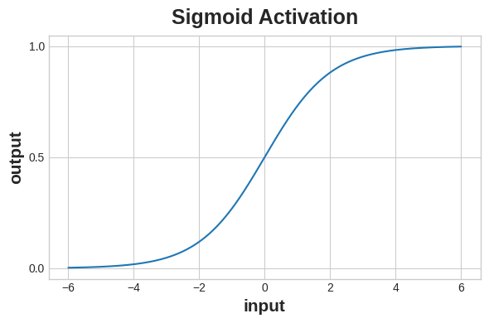

The sigmoid function maps real numbers into the interval [0,1]

.

To get the final class prediction, we define a *threshold* probability. Typically this will be 0.5, so that rounding will give us the correct class: below 0.5 means the class with label 0 and 0.5 or above means the class with label 1. A 0.5 threshold is what Keras uses by default with its [accuracy metric](https://www.tensorflow.org/api_docs/python/tf/keras/metrics/BinaryAccuracy).

Diagram of a binary classifier

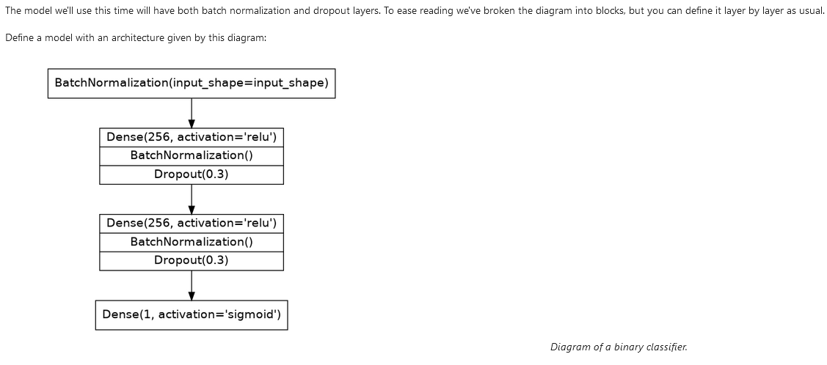

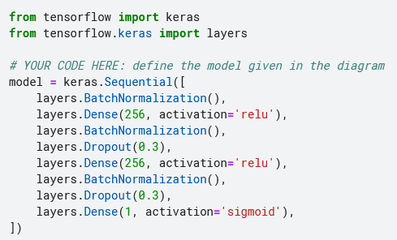

**16. Computer Vision**

**16.1 The Convolutional Classifier**

The neural networks that are best at this task are called **convolutional neural networks** (Sometimes we say **convnet** or **CNN** instead.) Convolution is the mathematical operation that gives the layers of a convnet their unique structure. In future lessons, you'll learn why this structure is so effective at solving computer vision problems.

**The Convolutional Classifier**

A convnet used for image classification consists of two parts: a **convolutional base** and a **dense head**.

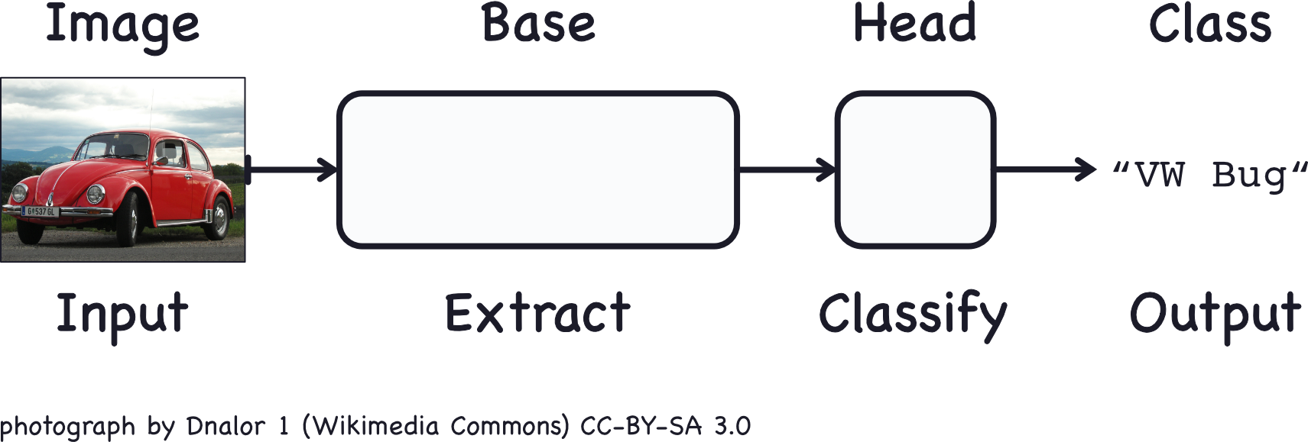

The base is used to **extract the features** from an image. It is formed primarily of layers performing the convolution operation, but often includes other kinds of layers as well. (You'll learn about these in the next lesson.)

The head is used to **determine the class** of the image. It is formed primarily of dense layers, but might include other layers like dropout.

What do we mean by visual feature? A feature could be a line, a color, a texture, a shape, a pattern -- or some complicated combination.

The whole process goes something like this:

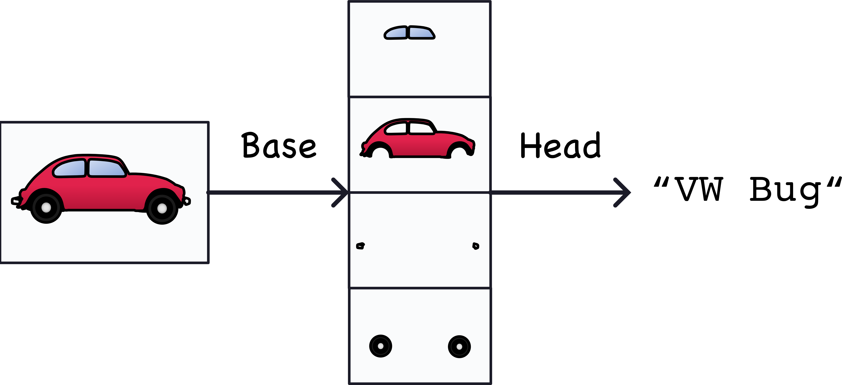

The features actually extracted look a bit different, but it gives the idea.

**Training the Classifier**

The goal of the network during training is to learn two things:

1. which features to extract from an image (base),
2. which class goes with what features (head).

These days, convnets are rarely trained from scratch. More often, we **reuse the base of a pretrained model**. To the pretrained base we then **attach an untrained head**. In other words, we reuse the part of a network that has already learned to do *1. Extract features*, and attach to it some fresh layers to learn *2. Classify*.

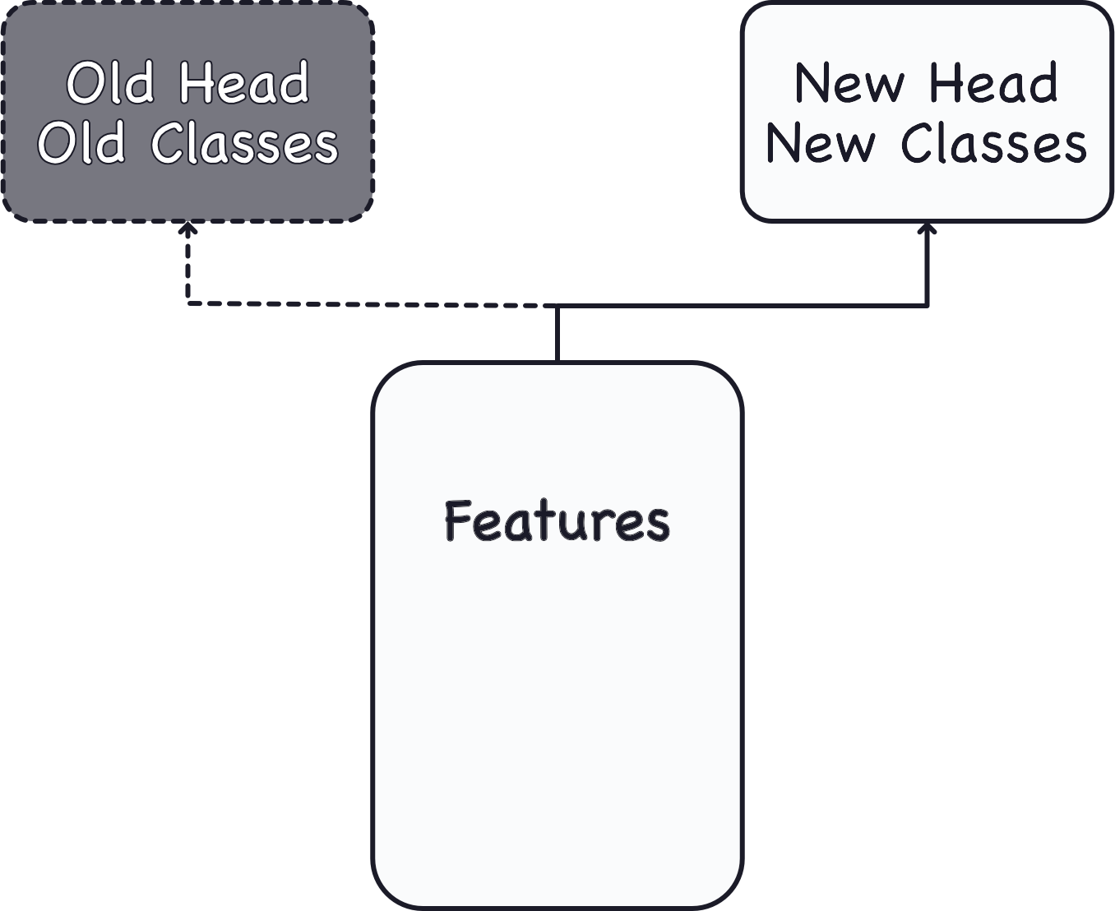

Because the head usually consists of only a few dense layers, very accurate classifiers can be created from relatively little data.

Reusing a pretrained model is a technique known as **transfer learning**. It is so effective, that almost every image classifier these days will make use of it.

**Conclusion**

In this lesson, we learned about the structure of a convnet classifier: a **head** to act as a classifier atop of a **base** which performs the feature extraction.

The head, essentially, is an ordinary classifier like you learned about in the introductory course. For features, it uses those features extracted by the base. This is the basic idea behind convolutional classifiers: that we can attach a unit that performs feature engineering to the classifier itself.

This is one of the big advantages deep neural networks have over traditional machine learning models: given the right network structure, the deep neural net can learn how to engineer the features it needs to solve its problem.

**16.2 Convolution and ReLU**

In the last lesson, we saw that a convolutional classifier has two parts: a convolutional **base** and a **head** of dense layers. We learned that the job of the base is to extract visual features from an image, which the head would then use to classify the image.

Over the next few lessons, we're going to learn about the two most important types of layers that you'll usually find in the base of a convolutional image classifier. These are the **convolutional layer** with **ReLU activation**, and the **maximum pooling layer**. In Lesson 5, you'll learn how to design your own convnet by composing these layers into blocks that perform the feature extraction.

This lesson is about the convolutional layer with its ReLU activation function.

**Feature Extraction**

Before we get into the details of convolution, let's discuss the *purpose* of these layers in the network. We're going to see how these three operations (convolution, ReLU, and maximum pooling) are used to implement the feature extraction process.

The **feature extraction** performed by the base consists of **three basic operations**:

1. **Filter** an image for a particular feature (convolution)
2. **Detect** that feature within the filtered image (ReLU)
3. **Condense** the image to enhance the features (maximum pooling)

The next figure illustrates this process. You can see how these three operations are able to isolate some particular characteristic of the original image (in this case, horizontal lines).

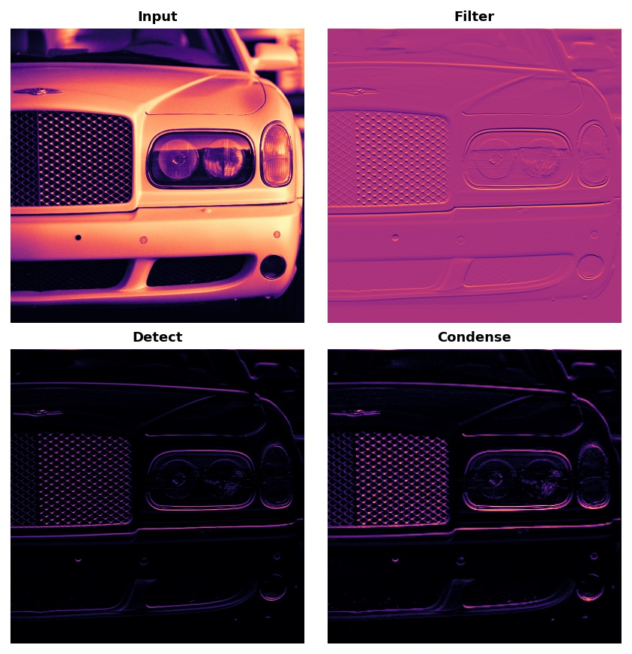

The three steps of feature extraction.

Typically, the network will perform several extractions in parallel on a single image. In modern convnets, it's not uncommon for the final layer in the base to be producing over 1000 unique visual features.

**Weights**

The **weights** a convnet learns during training are primarily contained in its convolutional layers. These weights we call **kernels**. We can represent them as small arrays:

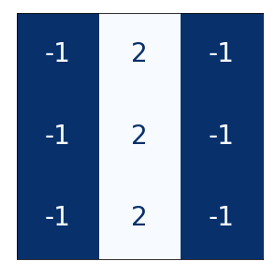

A kernel operates by scanning over an image and producing a *weighted sum* of pixel values. In this way, a kernel will act sort of like a polarized lens, emphasizing or deemphasizing certain patterns of information.

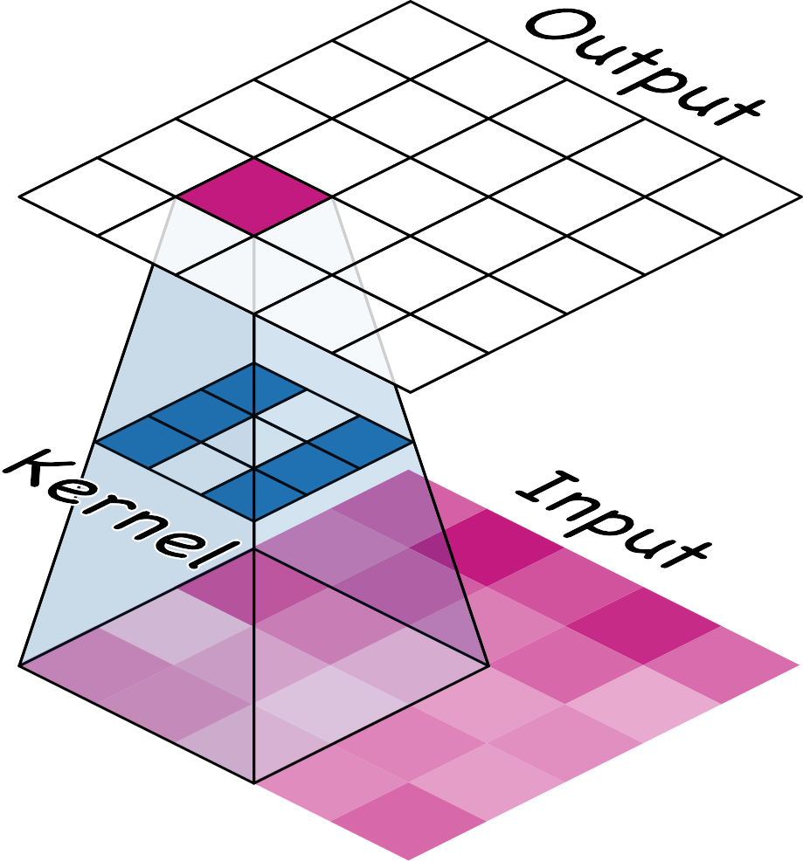

A kernel acts as a kind of lens.

Kernels define how a convolutional layer is connected to the layer that follows. The kernel above will connect each neuron in the output to nine neurons in the input. By setting the dimensions of the kernels with kernel_size, you are telling the convnet how to form these connections. Most often, a kernel will have odd-numbered dimensions -- like kernel_size=(3, 3) or (5, 5) -- so that a single pixel sits at the center, but this is not a requirement.

The kernels in a convolutional layer determine what kinds of features it creates. During training, a convnet tries to learn what features it needs to solve the classification problem. This means finding the best values for its kernels.

**Activations**

The **activations** in the network we call **feature maps**. They are what result when we apply a filter to an image; they contain the visual features the kernel extracts. Here are a few kernels pictured with feature maps they produced.

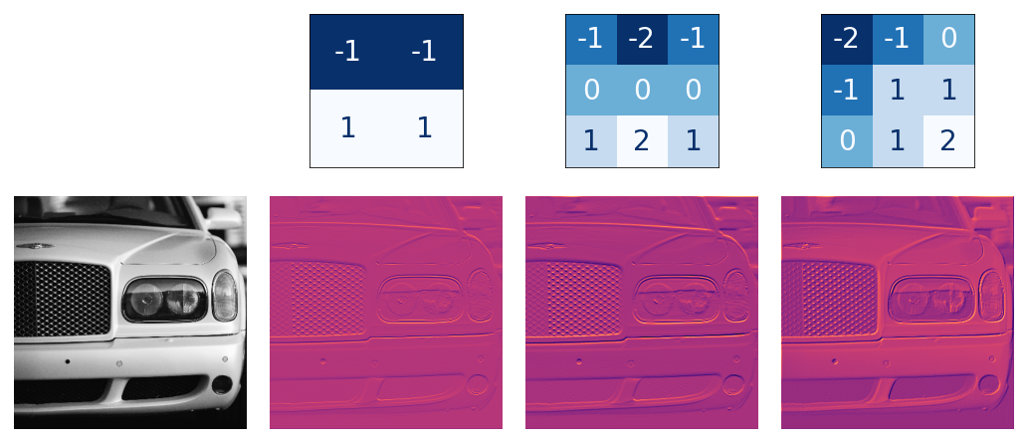

Kernels and features.

From the pattern of numbers in the kernel, you can tell the kinds of feature maps it creates. Generally, what a convolution accentuates in its inputs will match the shape of the *positive* numbers in the kernel. The left and middle kernels above will both filter for horizontal shapes.

With the filters parameter, you tell the convolutional layer how many feature maps you want it to create as output.

**Detect with ReLU**

After filtering, the feature maps pass through the activation function. The **rectifier function** has a graph like this:

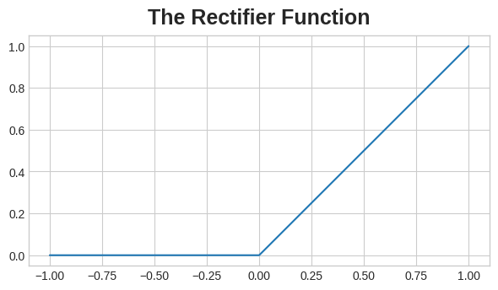

The graph of the rectifier function looks like a line with the negative part "rectified" to 0.

A neuron with a rectifier attached is called a *rectified linear unit*. For that reason, we might also call the rectifier function the **ReLU activation** or even the ReLU function.

The ReLU activation can be defined in its own Activation layer, but most often you'll just include it as the activation function of Conv2D.

You could think about the activation function as scoring pixel values according to some measure of importance. The ReLU activation says that negative values are not important and so sets them to 0. ("Everything unimportant is equally unimportant.")

Here is ReLU applied the feature maps above. Notice how it succeeds at isolating the features.

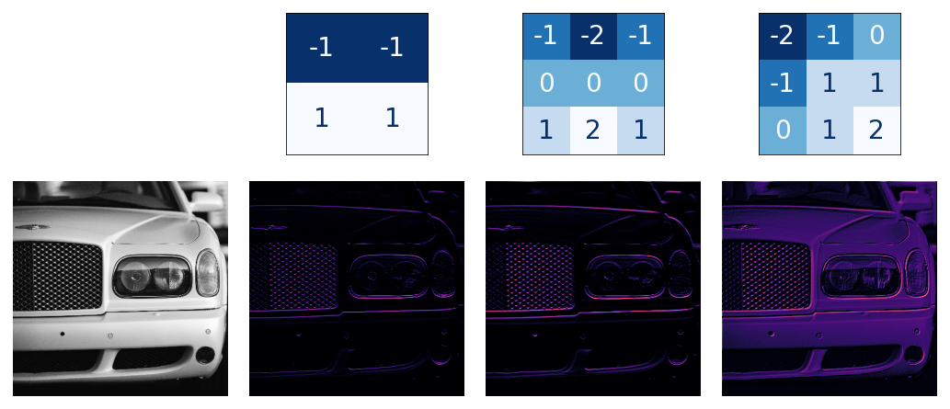

Like other activation functions, the ReLU function is **nonlinear**. Essentially this means that the total effect of all the layers in the network becomes different than what you would get by just adding the effects together -- which would be the same as what you could achieve with only a single layer. The nonlinearity ensures features will combine in interesting ways as they move deeper into the network. (We'll explore this "feature compounding" more in Lesson 5.)

**16.3 Maximum Pooling**

In Lesson 2 we began our discussion of how the base in a convnet performs feature extraction. We learned about how the first two operations in this process occur in a Conv2D layer with relu activation.

In this lesson, we'll look at the third (and final) operation in this sequence: **condense** with **maximum pooling**, which in Keras is done by a MaxPool2D layer.

A MaxPool2D layer is much like a Conv2D layer, except that it uses a simple maximum function instead of a kernel, with the pool_size parameter analogous to kernel_size. A MaxPool2D layer doesn't have any trainable weights like a convolutional layer does in its kernel, however.

Let's take another look at the extraction figure from the last lesson. Remember that MaxPool2D is the **Condense** step.



Notice that after applying the ReLU function (**Detect**) the feature map ends up with a lot of "dead space," that is, large areas containing only 0's (the black areas in the image). Having to carry these 0 activations through the entire network would increase the size of the model without adding much useful information. Instead, we would like to *condense* the feature map to retain only the most useful part -- the feature itself.

This in fact is what **maximum pooling** does. Max pooling takes a patch of activations in the original feature map and replaces them with the maximum activation in that patch.

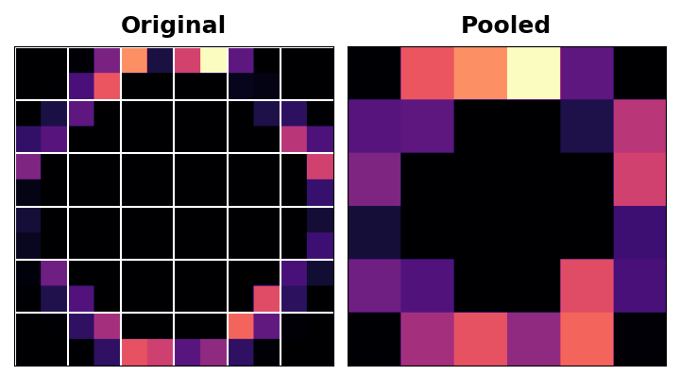

When applied after the ReLU activation, it has the effect of "intensifying" features. The pooling step increases the proportion of active pixels to zero pixels.

**Translation Invariance**

We called the zero-pixels "unimportant". Does this mean they carry no information at all? In fact, the zero-pixels carry *positional information*. The blank space still positions the feature within the image. When MaxPool2D removes some of these pixels, it removes some of the positional information in the feature map. This gives a convnet a property called **translation invariance**. This means that a convnet with maximum pooling will tend not to distinguish features by their *location* in the image. ("Translation" is the mathematical word for changing the position of something without rotating it or changing its shape or size.)

Watch what happens when we repeatedly apply maximum pooling to the following feature map.

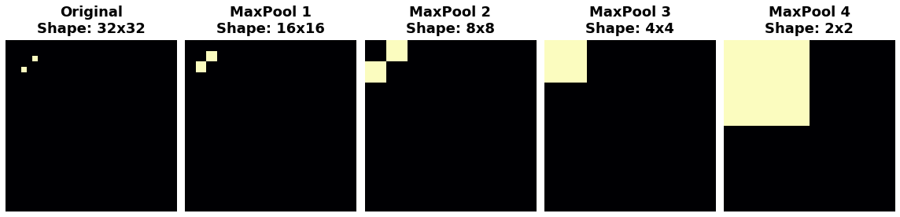

The two dots in the original image became indistinguishable after repeated pooling. In other words, pooling destroyed some of their positional information. Since the network can no longer distinguish between them in the feature maps, it can't distinguish them in the original image either: it has become *invariant* to that difference in position.

In fact, pooling only creates translation invariance in a network *over small distances*, as with the two dots in the image. Features that begin far apart will remain distinct after pooling; only *some* of the positional information was lost, but not all of it.

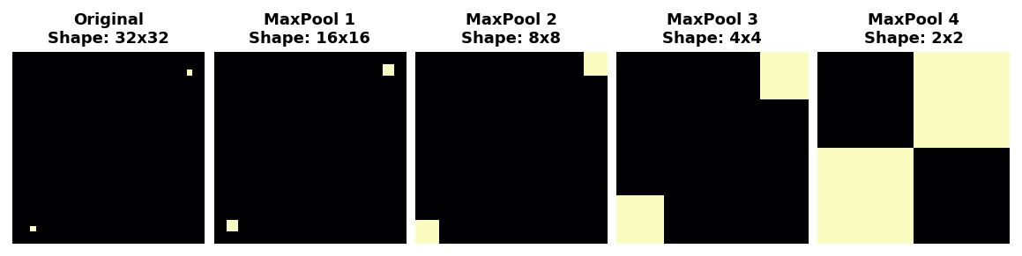

This invariance to small differences in the positions of features is a nice property for an image classifier to have. Just because of differences in perspective or framing, the same kind of feature might be positioned in various parts of the original image, but we would still like for the classifier to recognize that they are the same. Because this invariance is *built into* the network, we can get away with using much less data for training: we no longer have to teach it to ignore that difference. This gives convolutional networks a big efficiency advantage over a network with only dense layers. (You'll see another way to get invariance for free in **Lesson 6** with **Data Augmentation**!)

**16.4 The Sliding Window**

In the previous two lessons, we learned about the three operations that carry out feature extraction from an image:

1. *filter* with a **convolution** layer
2. *detect* with **ReLU** activation
3. *condense* with a **maximum pooling** layer

The convolution and pooling operations share a common feature: they are both performed over a **sliding window**. With convolution, this "window" is given by the dimensions of the kernel, the parameter kernel_size. With pooling, it is the pooling window, given by pool_size.



There are two additional parameters affecting both convolution and pooling layers -- these are the strides of the window and whether to use padding at the image edges. The strides parameter says how far the window should move at each step, and the padding parameter describes how we handle the pixels at the edges of the input.

**Stride**

The distance the window moves at each step is called the **stride**. We need to specify the stride in both dimensions of the image: one for moving left to right and one for moving top to bottom. This animation shows strides=(2, 2), a movement of 2 pixels each step.



What effect does the stride have? Whenever the stride in either direction is greater than 1, the sliding window will skip over some of the pixels in the input at each step.

Because we want high-quality features to use for classification, convolutional layers will most often have strides=(1, 1). Increasing the stride means that we miss out on potentially valuble information in our summary. Maximum pooling layers, however, will almost always have stride values greater than 1, like (2, 2) or (3, 3), but not larger than the window itself.

Finally, note that when the value of the strides is the same number in both directions, you only need to set that number; for instance, instead of strides=(2, 2), you could use strides=2 for the parameter setting.

**Padding**

When performing the sliding window computation, there is a question as to what to do at the boundaries of the input. Staying entirely inside the input image means the window will never sit squarely over these boundary pixels like it does for every other pixel in the input. Since we aren't treating all the pixels exactly the same, could there be a problem?

What the convolution does with these boundary values is determined by its padding parameter. In TensorFlow, you have two choices: either padding='same' or padding='valid'. There are trade-offs with each.

When we set padding='valid', the convolution window will stay entirely inside the input. The drawback is that the output shrinks (loses pixels), and shrinks more for larger kernels. This will limit the number of layers the network can contain, especially when inputs are small in size.

The alternative is to use padding='same'. The trick here is to **pad** the input with 0's around its borders, using just enough 0's to make the size of the output the *same* as the size of the input. This can have the effect however of diluting the influence of pixels at the borders. The animation below shows a sliding window with 'same' padding.



The VGG model we've been looking at uses same padding for all of its convolutional layers. Most modern convnets will use some combination of the two. (Another parameter to tune!)

**16.5 Custom Convnets**

**Simple to Refined**

In the last three lessons, we saw how convolutional networks perform **feature extraction** through three operations: **filter**, **detect**, and **condense**. A single round of feature extraction can only extract relatively simple features from an image, things like simple lines or contrasts. These are too simple to solve most classification problems. Instead, convnets will repeat this extraction over and over, so that the features become more complex and refined as they travel deeper into the network.

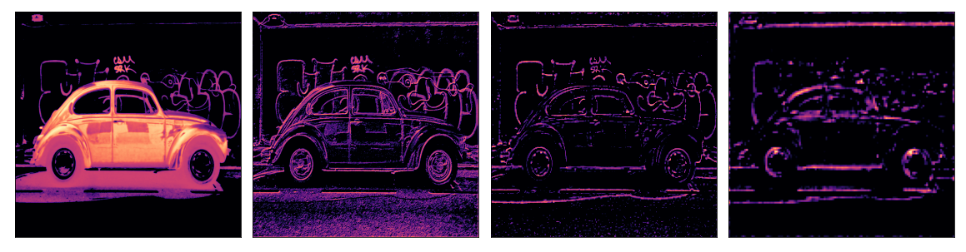

**Convolutional Blocks**

It does this by passing them through long chains of **convolutional blocks** which perform this extraction.



These convolutional blocks are stacks of Conv2D and MaxPool2D layers, whose role in feature extraction we learned about in the last few lessons.

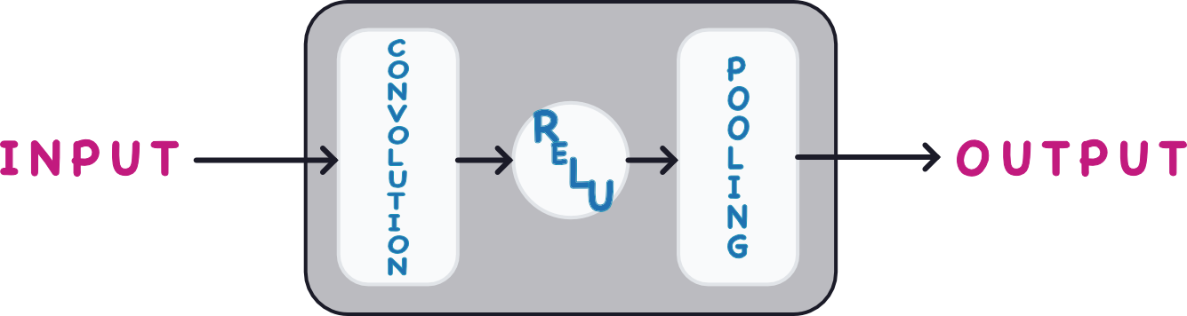

Each block represents a round of extraction, and by composing these blocks the convnet can combine and recombine the features produced, growing them and shaping them to better fit the problem at hand. The deep structure of modern convnets is what allows this sophisticated feature engineering and has been largely responsible for their superior performance.

**16.6 Data Augmentation**

**The Usefulness of Fake Data**

The best way to improve the performance of a machine learning model is to train it on more data. The more examples the model has to learn from, the better it will be able to recognize which differences in images matter and which do not. More data helps the model to *generalize* better.

One easy way of getting more data is to use the data you already have. If we can transform the images in our dataset in ways that preserve the class, we can teach our classifier to ignore those kinds of transformations. For instance, whether a car is facing left or right in a photo doesn't change the fact that it is a *Car* and not a *Truck*. So, if we **augment** our training data with flipped images, our classifier will learn that "left or right" is a difference it should ignore.

And that's the whole idea behind data augmentation: add in some extra fake data that looks reasonably like the real data and your classifier will improve.

**Using Data Augmentation**

Typically, many kinds of transformation are used when augmenting a dataset. These might include rotating the image, adjusting the color or contrast, warping the image, or many other things, usually applied in combination. Here is a sample of the different ways a single image might be transformed.

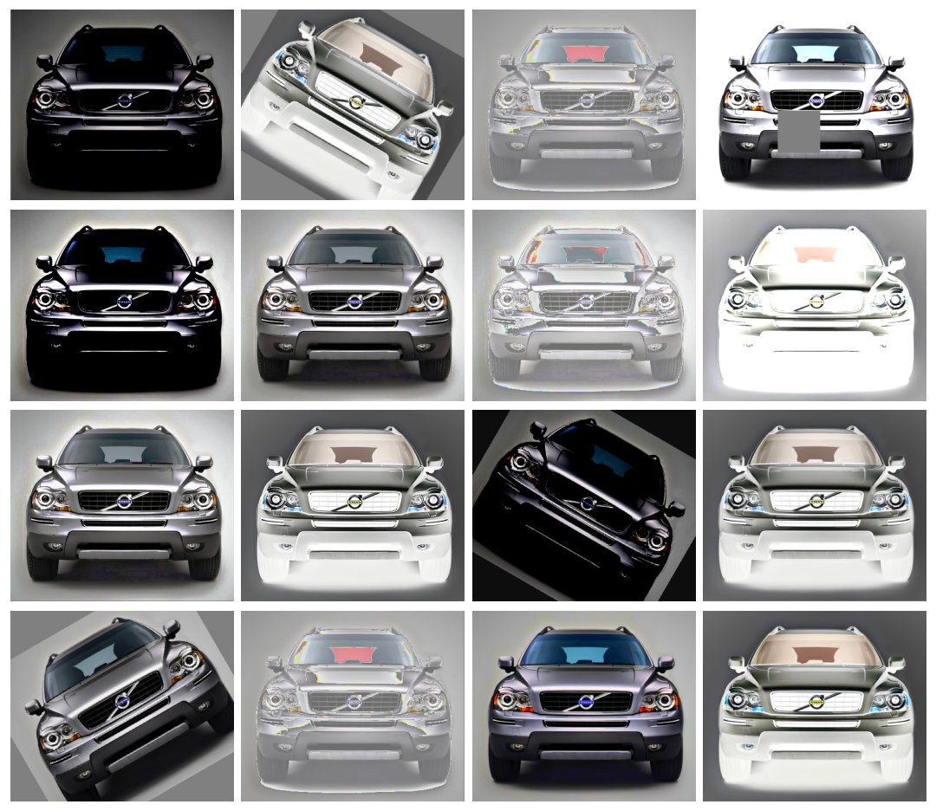

Data augmentation is usually done *online*, meaning, as the images are being fed into the network for training. Recall that training is usually done on mini-batches of data. This is what a batch of 16 images might look like when data augmentation is used.

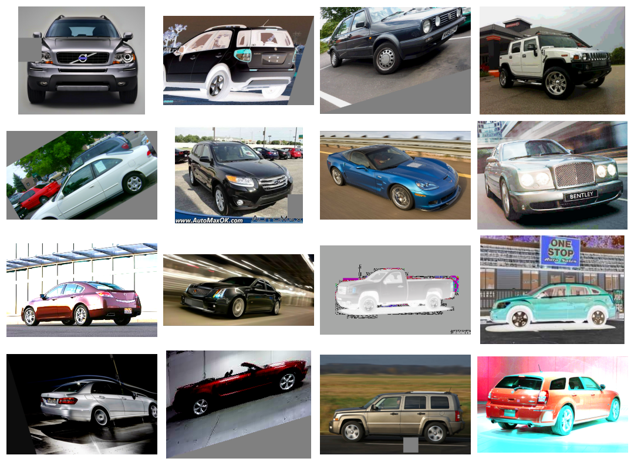

Each time an image is used during training, a new random transformation is applied. This way, the model is always seeing something a little different than what it's seen before. This extra variance in the training data is what helps the model on new data.

It's important to remember though that not every transformation will be useful on a given problem. Most importantly, whatever transformations you use should not mix up the classes. If you were training a [digit recognizer](https://www.kaggle.com/c/digit-recognizer), for instance, rotating images would mix up '9's and '6's. In the end, the best approach for finding good augmentations is the same as with most ML problems: try it and see!

**Training with Data Augmentation**

Keras lets you augment your data in two ways. The first way is to include it in the data pipeline with a function like [ImageDataGenerator](https://www.tensorflow.org/api_docs/python/tf/keras/preprocessing/image/ImageDataGenerator). The second way is to include it in the model definition by using Keras's **preprocessing layers**. This is the approach that we'll take. The primary advantage for us is that the image transformations will be computed on the GPU instead of the CPU, potentially speeding up training.

**17. Intro to Game AI and Reinforcement Learning**

**17.1 Play the Game**